**EXPERIMENT NO. 03**

|  |
| --- |
| NAME: Ayush Vinod Upadhyay  ROLL NO: I025  SAP ID: 60003220131  BRANCH: Information Technology  BATCH: 1 |

**CO/LO:** **Develop web applications.**

**AIM / OBJECTIVE:** Design responsive web site using bootstrap

**DESCRIPTION OF EXPERIMENT:**

**Bootstrap Components:Navbar:** The navbar component is used for creating the navigation bar at the top of the page. It provides a responsive navigation bar that collapses on smaller screens.

**Container:** The container class is used to create a fixed-width container to hold the content. It helps in creating a consistent layout by providing a responsive container.

**Card:**The card component is used to create a container for content, usually with a title, image, and text.Cards are versatile components used for displaying content in an organized and visually appealing way.

**Button:**The btn class is used to create buttons. Bootstrap buttons come with various styles and sizes, providing a consistent look and feel.

**Image:** The img tag is used to display images. Images are a fundamental part of web design, and Bootstrap helps in handling their responsiveness.

**Form Components:**Various form components like form-group, form-control, form-check, and form-select are used. These components help in creating structured and styled forms for user input.

**Checkbox:**The form-check class is used for styling checkboxes. Bootstrap styles checkboxes to enhance their appearance and improve user experience.

**SOURCE CODE:**

<!DOCTYPE html>

<html lang="en">

<head>

    <meta charset="UTF-8">

    <meta name="viewport" content="width=device-width, initial-scale=1.0">

    <title>Bootstrap</title>

    <link href="https://cdn.jsdelivr.net/npm/bootstrap@5.0.2/dist/css/bootstrap.min.css" rel="stylesheet" integrity="sha384-EVSTQN3/azprG1Anm3QDgpJLIm9Nao0Yz1ztcQTwFspd3yD65VohhpuuCOmLASjC" crossorigin="anonymous">

    <link rel="stylesheet" href="script.css">

</head>

<body>

    <nav class="navbar navbar-expand-lg navbar-light bg-light">

        <div class="container-fluid">

          <a class="navbar-brand" href="#">BootStrap</a>

          <button class="navbar-toggler" type="button" data-bs-toggle="collapse" data-bs-target="#navbarSupportedContent" aria-controls="navbarSupportedContent" aria-expanded="false" aria-label="Toggle navigation">

            <span class="navbar-toggler-icon"></span>

          </button>

          <div class="collapse navbar-collapse" id="navbarSupportedContent">

            <ul class="navbar-nav me-auto mb-2 mb-lg-0">

              <li class="nav-item">

                <a class="nav-link active" aria-current="page" href="Home.html">Home</a>

              </li>

              <li class="nav-item">

                <a class="nav-link" href="Login.html">Login</a>

              </li>

              <li class="nav-item">

                <a class="nav-link" href="SignUp.html">SignUp</a>

              </li>

            </ul>

          </div>

        </div>

      </nav>

      <div class="container">

        <div class="card" style="width: 18rem;">

            <img class="card-img-top" src="mahagony.jpeg" alt="Card image cap">

            <div class="card-body">

              <h5 class="card-title">Indian Mahogany</h5>

              <p class="card-text">This tree is very famous for its beautiful colours and sturdiness. The bark of this tree is typically used for making musical instruments and furniture.</p>

              <a href="#" class="btn btn-primary">Read More</a>

            </div>

          </div>

          <div class="card" style="width: 18rem;">

            <img class="card-img-top" src="gulmohar.jpeg" alt="Card image cap">

            <div class="card-body">

              <h5 class="card-title">Gulmohar</h5>

              <p class="card-text">This tree is a flowering tree with bright orange flowers and a wide canopy. It is mostly ornamental and the wood is used for making handles for tools and combs since it is very durable.</p>

              <a href="#" class="btn btn-primary">Read More</a>

            </div>

          </div>

          <div class="card" style="width: 18rem;">

            <img class="card-img-top" src="amla.jpeg" alt="Card image cap">

            <div class="card-body">

              <h5 class="card-title">Amla</h5>

              <p class="card-text">This is a deciduous tree and grows fruits that are round and green. The fruit is rich in vitamin C and used to cure insomnia. It is used in hair dyes and cosmetics as well. </p>

              <a href="#" class="btn btn-primary">Read More</a>

            </div>

          </div>

          <div class="card" style="width: 18rem;">

            <img class="card-img-top" src="peepal.jpeg" alt="Card image cap">

            <div class="card-body">

              <h5 class="card-title">Peepal</h5>

              <p class="card-text">This is an evergreen tree and is also worshipped in many parts of the country. It has heart-shaped leaves that make it so distinctly different. </p>

              <a href="#" class="btn btn-primary">Read More</a>

            </div>

          </div>

      </div>

    <script src="https://cdn.jsdelivr.net/np

m/@popperjs/core@2.9.2/dist/umd/popper.min.js" integrity="sha384-IQsoLXl5PILFhosVNubq5LC7Qb9DXgDA9i+tQ8Zj3iwWAwPtgFTxbJ8NT4GN1R8p" crossorigin="anonymous"></script>

    <script src="https://cdn.jsdelivr.net/npm/bootstrap@5.0.2/dist/js/bootstrap.min.js" integrity="sha384-cVKIPhGWiC2Al4u+LWgxfKTRIcfu0JTxR+EQDz/bgldoEyl4H0zUF0QKbrJ0EcQF" crossorigin="anonymous"></script>

</body>

</html>

<!DOCTYPE html>

<html lang="en">

<head>

    <meta charset="UTF-8">

    <meta name="viewport" content="width=device-width, initial-scale=1.0">

    <title>Bootstrap Login</title>

    <link href="https://cdn.jsdelivr.net/npm/bootstrap@5.0.2/dist/css/bootstrap.min.css" rel="stylesheet" integrity="sha384-EVSTQN3/azprG1Anm3QDgpJLIm9Nao0Yz1ztcQTwFspd3yD65VohhpuuCOmLASjC" crossorigin="anonymous">

    <link rel="stylesheet" href="script.css">

</head>

<body>

    <nav class="navbar navbar-expand-lg navbar-light bg-light">

        <div class="container-fluid">

          <a class="navbar-brand" href="#">BootStrap</a>

          <button class="navbar-toggler" type="button" data-bs-toggle="collapse" data-bs-target="#navbarSupportedContent" aria-controls="navbarSupportedContent" aria-expanded="false" aria-label="Toggle navigation">

            <span class="navbar-toggler-icon"></span>

          </button>

          <div class="collapse navbar-collapse" id="navbarSupportedContent">

            <ul class="navbar-nav me-auto mb-2 mb-lg-0">

              <li class="nav-item">

                <a class="nav-link active" aria-current="page" href="Home.html">Home</a>

              </li>

              <li class="nav-item">

                <a class="nav-link" href="Login.html">Login</a>

              </li>

              <li class="nav-item">

                <a class="nav-link" href="SignUp.html">SignUp</a>

              </li>

            </ul>

          </div>

        </div>

      </nav>

      <div class="container">

        <div class="image-container" >

            <img src="login.png" alt="">

        </div>

        <div class="info-container">

            <section>

                <h1>LOGIN</h1>

                <form>

                      <div class="form-group">

                        <label for="exampleInputPassword1">Email</label>

                        <input type="email" class="form-control" id="exampleInputPassword1" placeholder="Enter email">

                      </div>

                      <div class="form-group">

                        <label for="exampleInputPassword1">Password</label>

                        <input type="password" class="form-control" id="exampleInputPassword1" placeholder="Password">

                      </div>

                      <div class="form-check">

                        <input type="checkbox" class="form-check-input" id="exampleCheck1">

                        <label class="form-check-label" for="exampleCheck1">I agree to terms and conditions</label>

                      </div>

                      <button type="submit" class="btn btn-primary">Submit</button>

                </form>

            </section>

        </div>

      </div>

    <script src="https://cdn.jsdelivr.net/npm/@popperjs/core@2.9.2/dist/umd/popper.min.js" integrity="sha384-IQsoLXl5PILFhosVNubq5LC7Qb9DXgDA9i+tQ8Zj3iwWAwPtgFTxbJ8NT4GN1R8p" crossorigin="anonymous"></script>

    <script src="https://cdn.jsdelivr.net/npm/bootstrap@5.0.2/dist/js/bootstrap.min.js" integrity="sha384-cVKIPhGWiC2Al4u+LWgxfKTRIcfu0JTxR+EQDz/bgldoEyl4H0zUF0QKbrJ0EcQF" crossorigin="anonymous"></script>

</body>

</html>

<!DOCTYPE html>

<html lang="en">

<head>

    <meta charset="UTF-8">

    <meta name="viewport" content="width=device-width, initial-scale=1.0">

    <title>Bootstrap SignUp</title>

    <link href="https://cdn.jsdelivr.net/npm/bootstrap@5.0.2/dist/css/bootstrap.min.css" rel="stylesheet" integrity="sha384-EVSTQN3/azprG1Anm3QDgpJLIm9Nao0Yz1ztcQTwFspd3yD65VohhpuuCOmLASjC" crossorigin="anonymous">

    <link rel="stylesheet" href="script.css">

</head>

<body>

    <nav class="navbar navbar-expand-lg navbar-light bg-light">

        <div class="container-fluid">

          <a class="navbar-brand" href="#">BootStrap</a>

          <button class="navbar-toggler" type="button" data-bs-toggle="collapse" data-bs-target="#navbarSupportedContent" aria-controls="navbarSupportedContent" aria-expanded="false" aria-label="Toggle navigation">

            <span class="navbar-toggler-icon"></span>

          </button>

          <div class="collapse navbar-collapse" id="navbarSupportedContent">

            <ul class="navbar-nav me-auto mb-2 mb-lg-0">

              <li class="nav-item">

                <a class="nav-link active" aria-current="page" href="Home.html">Home</a>

              </li>

              <li class="nav-item">

                <a class="nav-link" href="Login.html">Login</a>

              </li>

              <li class="nav-item">

                <a class="nav-link" href="SignUp.html">SignUp</a>

              </li>

            </ul>

          </div>

        </div>

      </nav>

      <div class="container">

        <div class="image-container" >

            <img src="signup.png" alt="">

        </div>

        <div class="info-container">

            <section>

                <h1>SIGN UP</h1>

                <form>

                        <div class="form-group">

                        <label for="exampleInputEmail1">Name</label>

                        <input type="text" class="form-control" id="exampleInputEmail1" aria-describedby="emailHelp" placeholder="Enter email">

                      </div>

                      <div class="form-group">

                        <label for="exampleInputPassword1">Email</label>

                        <input type="email" class="form-control" id="exampleInputPassword1" placeholder="Enter email">

                      </div>

                      <div class="form-group">

                        <label for="exampleInputPassword1">Phone Number</label>

                        <input type="number" class="form-control" id="exampleInputPassword1" placeholder="Enter Number">

                      </div>

                      <div class="form-group">

                        <label for="exampleInputPassword1">Date of Birth</label>

                        <input type="text" class="form-control" id="exampleInputPassword1" placeholder="dd/mm/yyyy">

                      </div>

                      <label for="exampleInputPassword1">Gender</label>

                      <select class="form-select" aria-label="Default select example">

                        <option selected>Select Gender</option>

                        <option value="1">Male</option>

                        <option value="2">Female</option>

                        <option value="3">None</option>

                      </select>

                      <div class="form-group">

                        <label for="exampleInputPassword1">Password</label>

                        <input type="password" class="form-control" id="exampleInputPassword1" placeholder="Password">

                      </div>

                      <div class="form-check">

                        <input type="checkbox" class="form-check-input" id="exampleCheck1">

                        <label class="form-check-label" for="exampleCheck1">I agree to terms and conditions</label>

                      </div>

                      <button type="submit" class="btn btn-primary">Submit</button>

                </form>

              </section>

        </div>

      </div>

    <script src="https://cdn.jsdelivr.net/npm/@popperjs/core@2.9.2/dist/umd/popper.min.js" integrity="sha384-IQsoLXl5PILFhosVNubq5LC7Qb9DXgDA9i+tQ8Zj3iwWAwPtgFTxbJ8NT4GN1R8p" crossorigin="anonymous"></script>

    <script src="https://cdn.jsdelivr.net/npm/bootstrap@5.0.2/dist/js/bootstrap.min.js" integrity="sha384-cVKIPhGWiC2Al4u+LWgxfKTRIcfu0JTxR+EQDz/bgldoEyl4H0zUF0QKbrJ0EcQF" crossorigin="anonymous"></script>

</body>

</html>

**OUTPUT:**

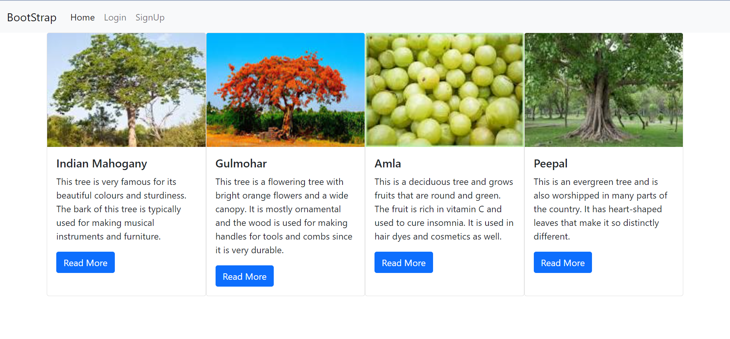 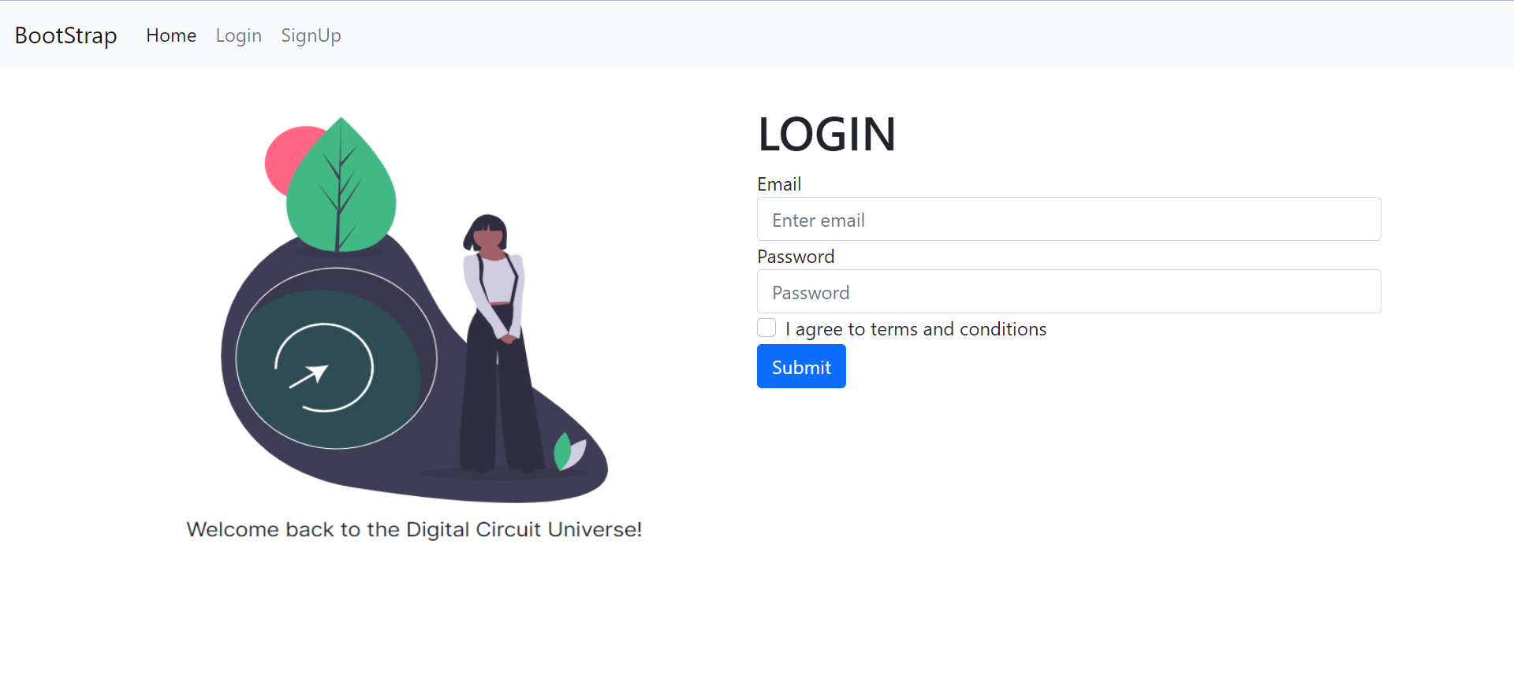 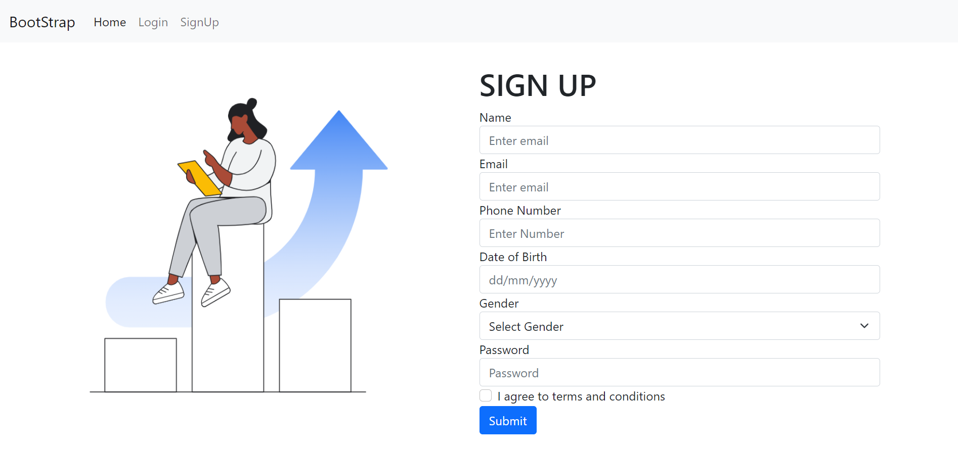

**CONCLUSION:**

I learnt about various bootstrap components and their usage while making a responsive website

**REFERENCES:** w3schools

**​Website References:​**BootStrap 5